**Lab Week2**

1. The network diagram and calendar views are presented as attachments at the end.
2. 1. Critical Path: 1,2,3,5,6,7,8,9,10,11

(Document hardware -> Document software -> Interview users -> Conduct needs analysis -> Build request for proposal -> Gather bids -> Choose vendor -> Install hardware -> Install software -> Conduct training)

* 1. The critical path is the longest sequence of tasks that determines the shortest time to complete the project. It tells us which tasks are most crucial. If any of these tasks get delayed, the entire project will be delayed. In this project, it means that if task3 is not completed, task5 cannot proceed, because the start of task5 requires the completion of both task3 and task4, and task4 has a shorter duration.

1. If starting from September 4, 2023, it will not end until January 30, 2024, requiring 107 days.
2. The task: conduct training will begin on January 26, 2024.
3. It will not affect. Because the critical path does not change.
4. It will impact the start date of the task "Conduct training" due to the influence on the critical path.
5. As the picture illustrates:

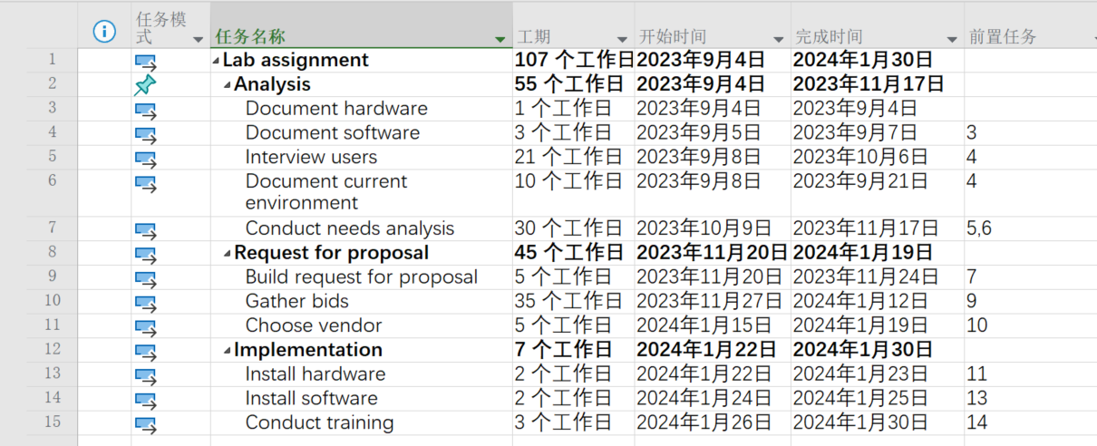

1. 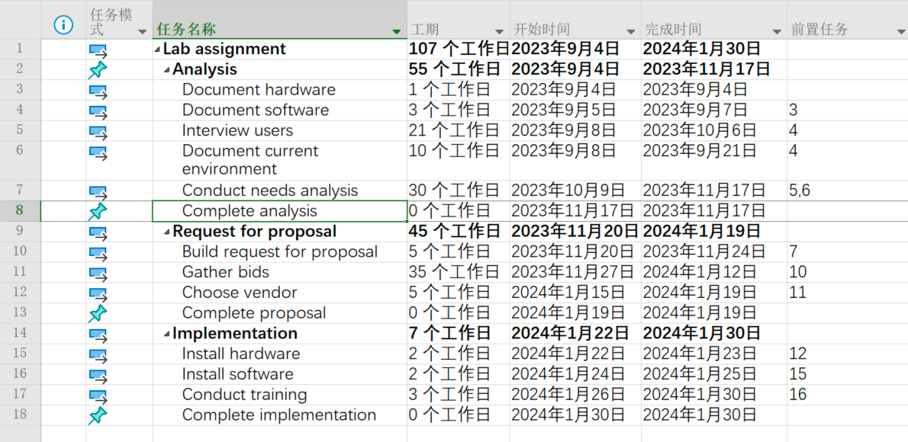As the picture illustrates:
2. As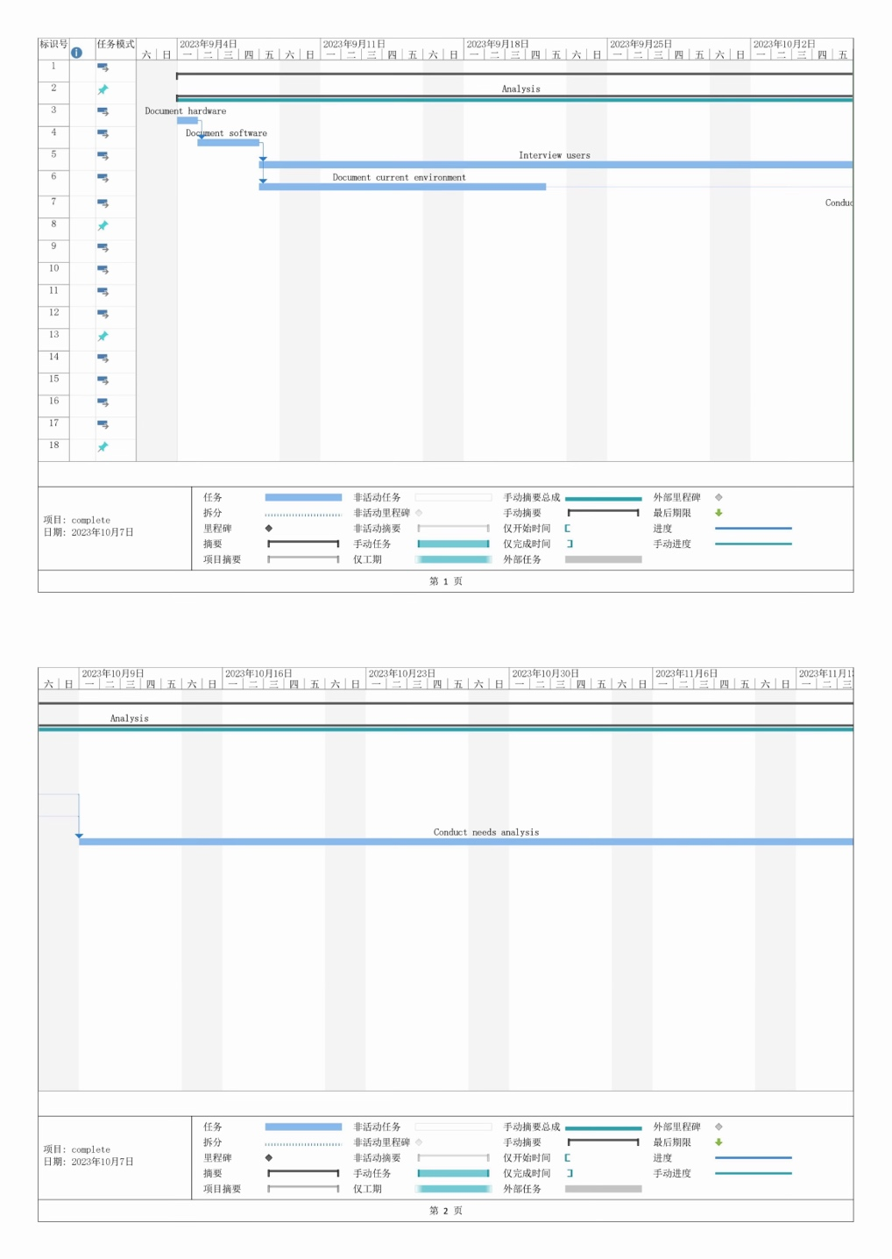 the picture illustrates:
3. 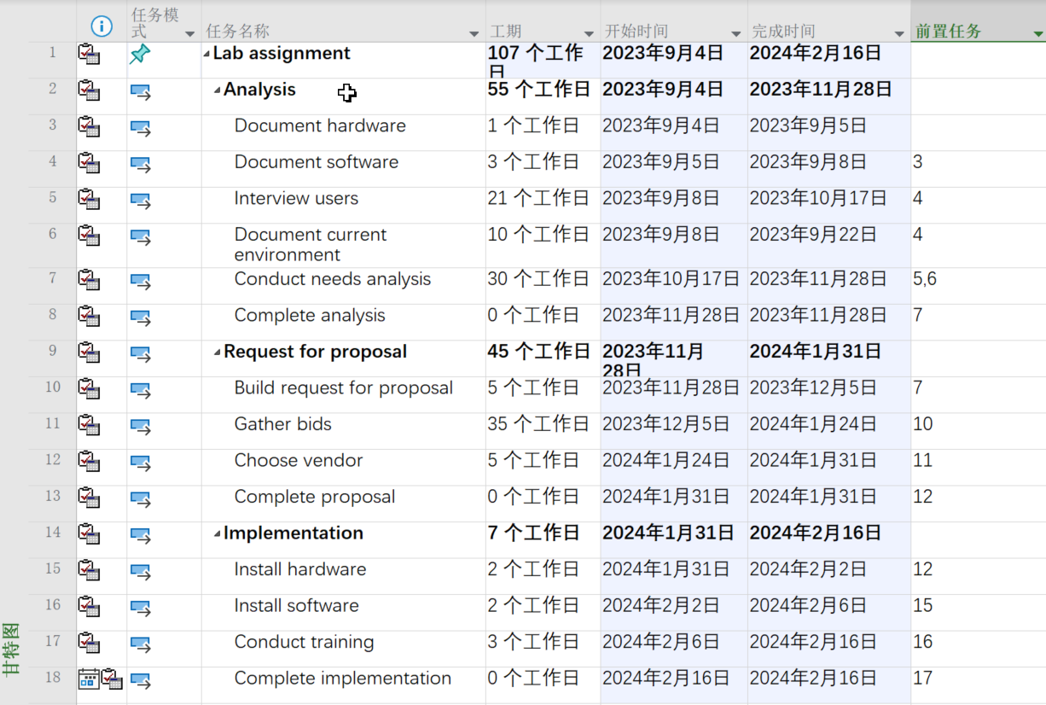The new completion date is February 16, 2024.
4. After setting a 40-hour workweek and designating the project type as a duration-based task, even when the work hours are adjusted to 35 hours, the project still concludes on February 16, 2024.
5. Considering the public holidays, we should commence the project on May 23, 2023, to ensure its completion by October 30, 2023.

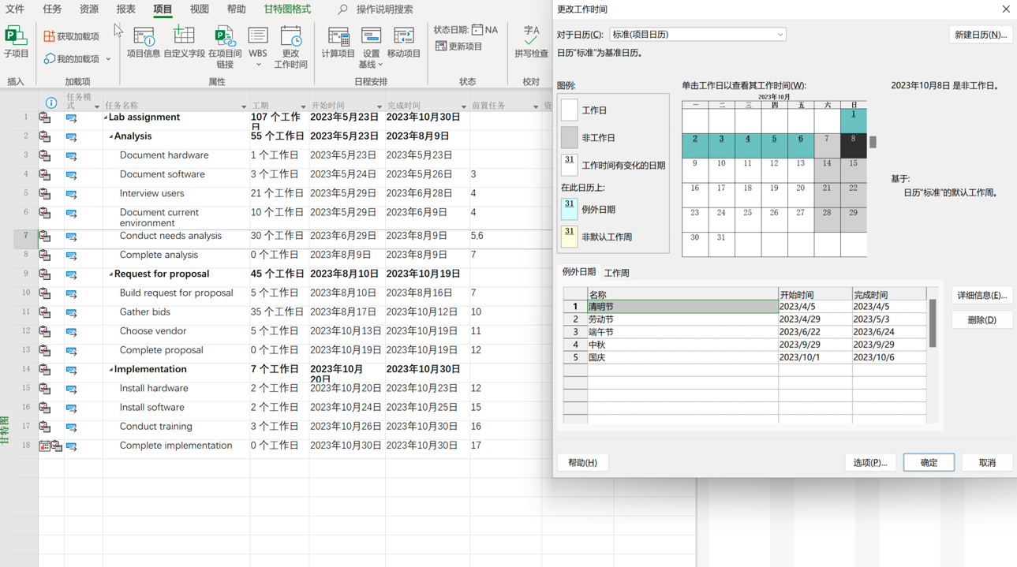

Excluding official holidays, the project should commence on June 02, 2023.

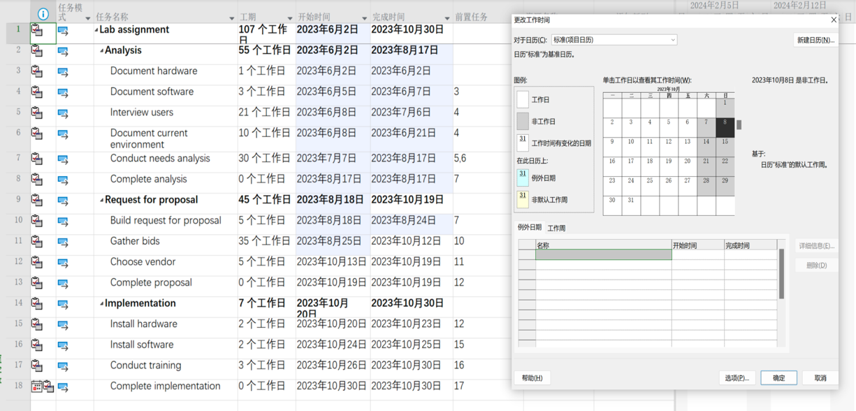

**Attachments：**

Network diagram

Calendar views